**RIZAL TECHNOLOGICAL UNIVERSITY**

College of Engineering, Architecture and Technology

Boni Campus

*Department of Information Technology*

An Individual activity submitted in partial fulfillment of the Requirement for the

subject

ITC211 | ITC211L

CEIT-37-303A

ITE212

Submitted by:

Pelegrino, Jayrald L.

Submitted to:

Mrs. Aphril Alcalde

Final Examination Part I

Document all features of the website that you have developed and presented. Take screenshots that illustrate every feature and include detailed descriptions of each. Submit a PDF copy of your output on or before 8:15 PM. Note that only the outputs submitted on time will be scored.

**Part II of the final examination will be posted at 8:30 PM**

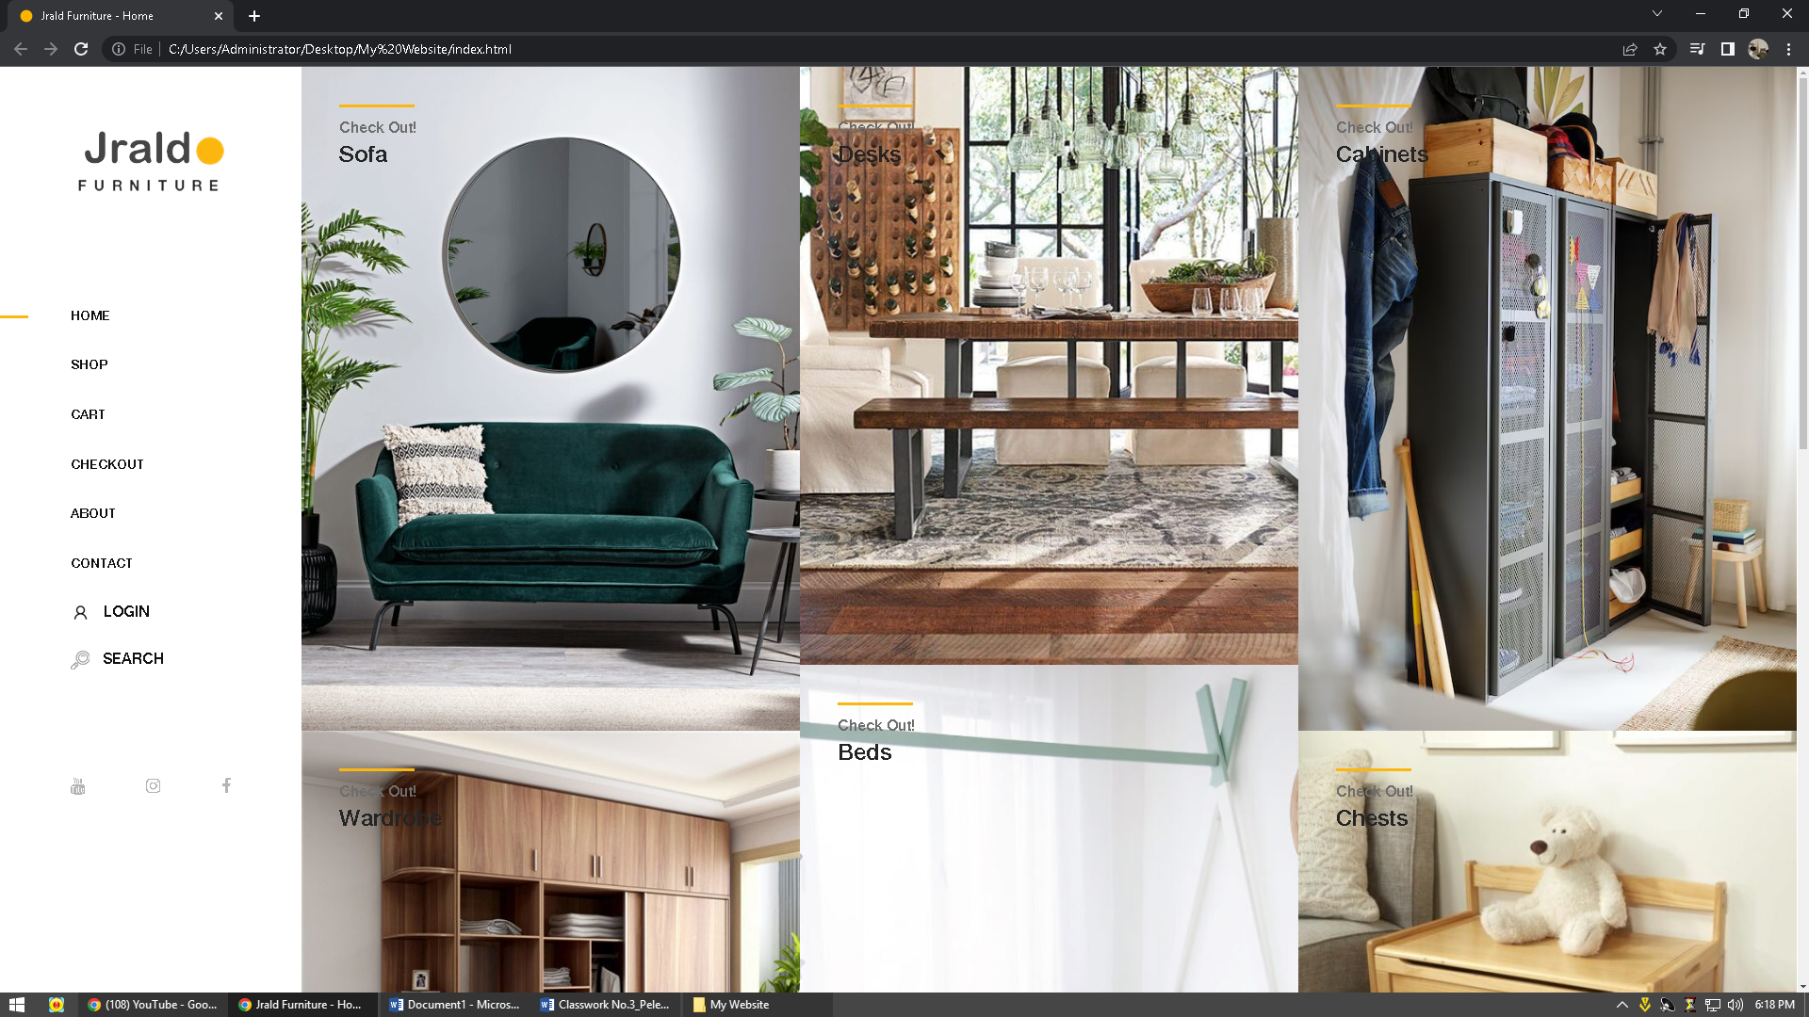

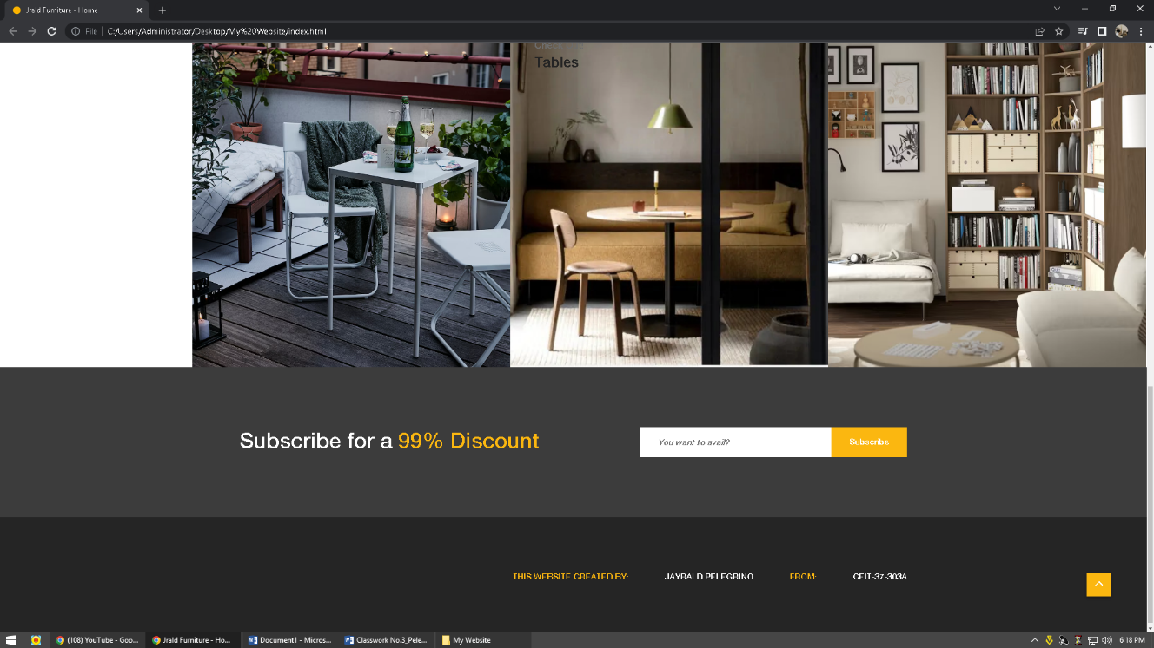

**Homepage**

Here on the homepage, you can see all the contents that are placed there, all of them are clickable, which is when you click on one right away, it's on the content of the furniture you chose and on each of its footers at the bottom, which is when you subscribe to the clinic. You will be directed to the login page which is responsive and all the buttons are clickable then, the menu bars on the side do not fade once you click on a new webpage

Among the user interface design principles discussed in class, For me on my website I made you can see a principle that Reduce users’ memory load that you can reduce short term memory load by designing screens where options are clearly visible, or using pull-down menus and icons and also my buttons are few but accurate. Moreover Make the user interface consistent, Because my buttons there are on the side, he is consistent, one of you is the clinic, which button is there except for the product and login page info. And can be seen in the following pictures:

**Reduce users’ memory load**

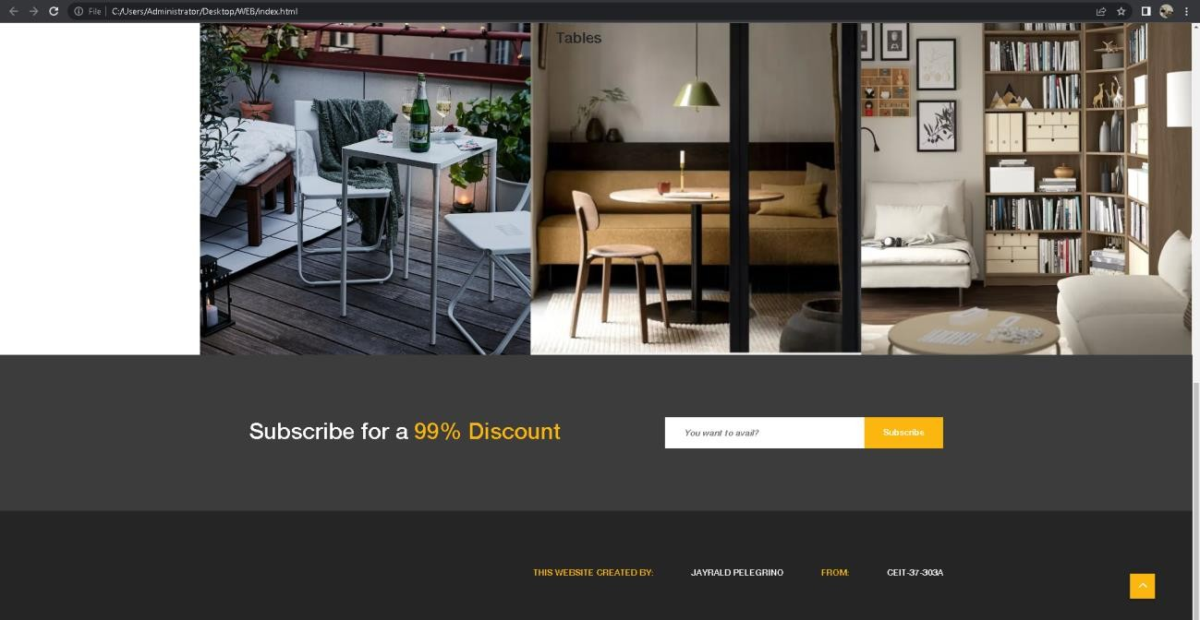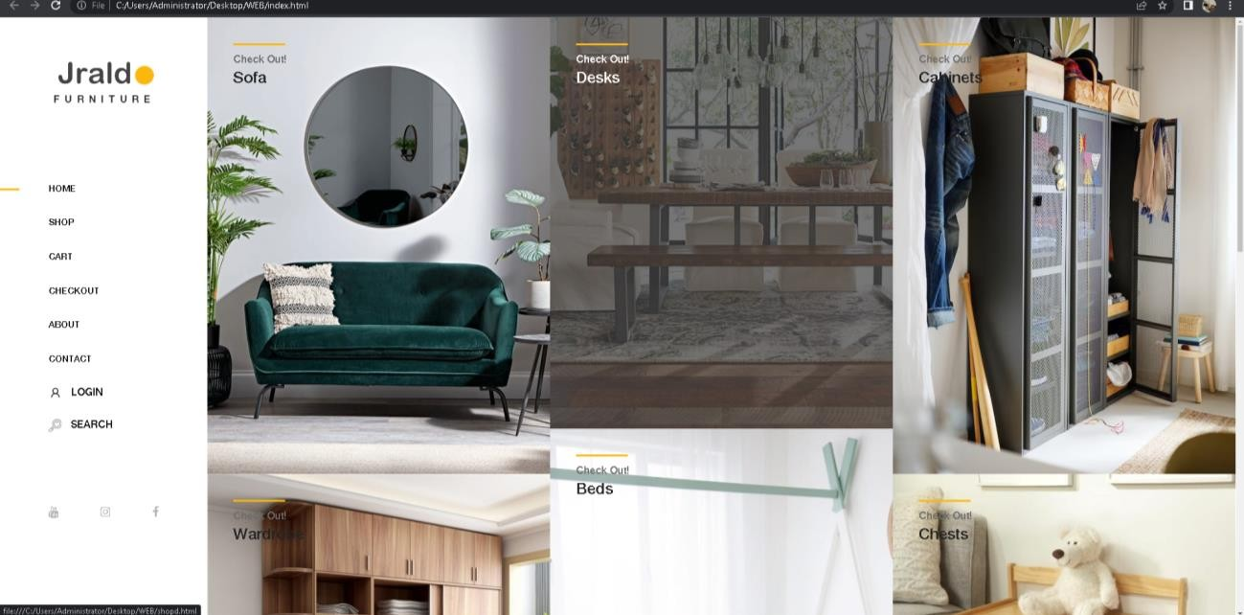

**Make the user interface consistency**

**Shop Page**

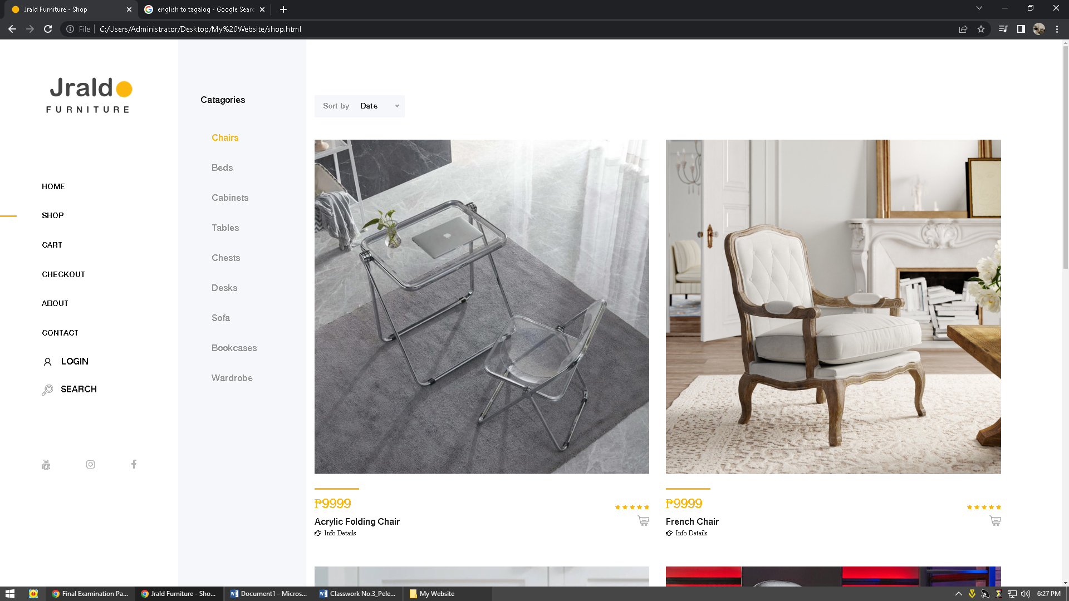

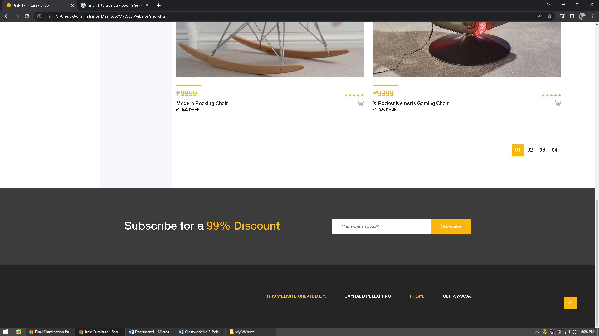

Here, which is the same as the footer, it is responsive for users who can use it and is not confused for users who will look at it, and its color is only consistent with the texts that I used that a user can see.

**Product Details Page**

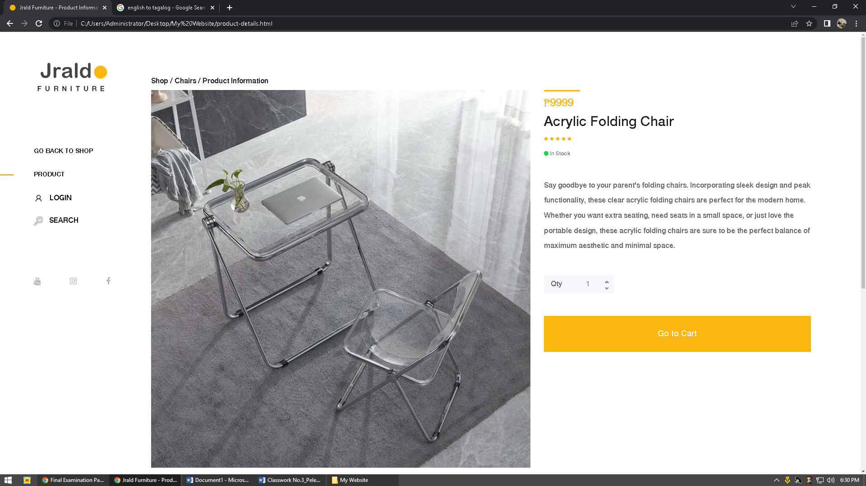

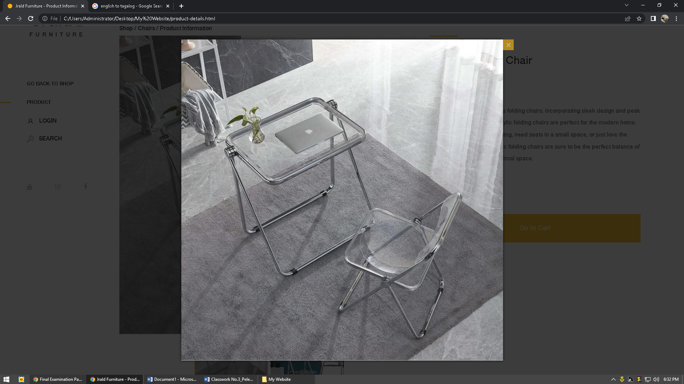

Here, the product is zozoomed and it has details, if you click the go to cart, it will go to the cart and our button is working if you can see it in the screenshot

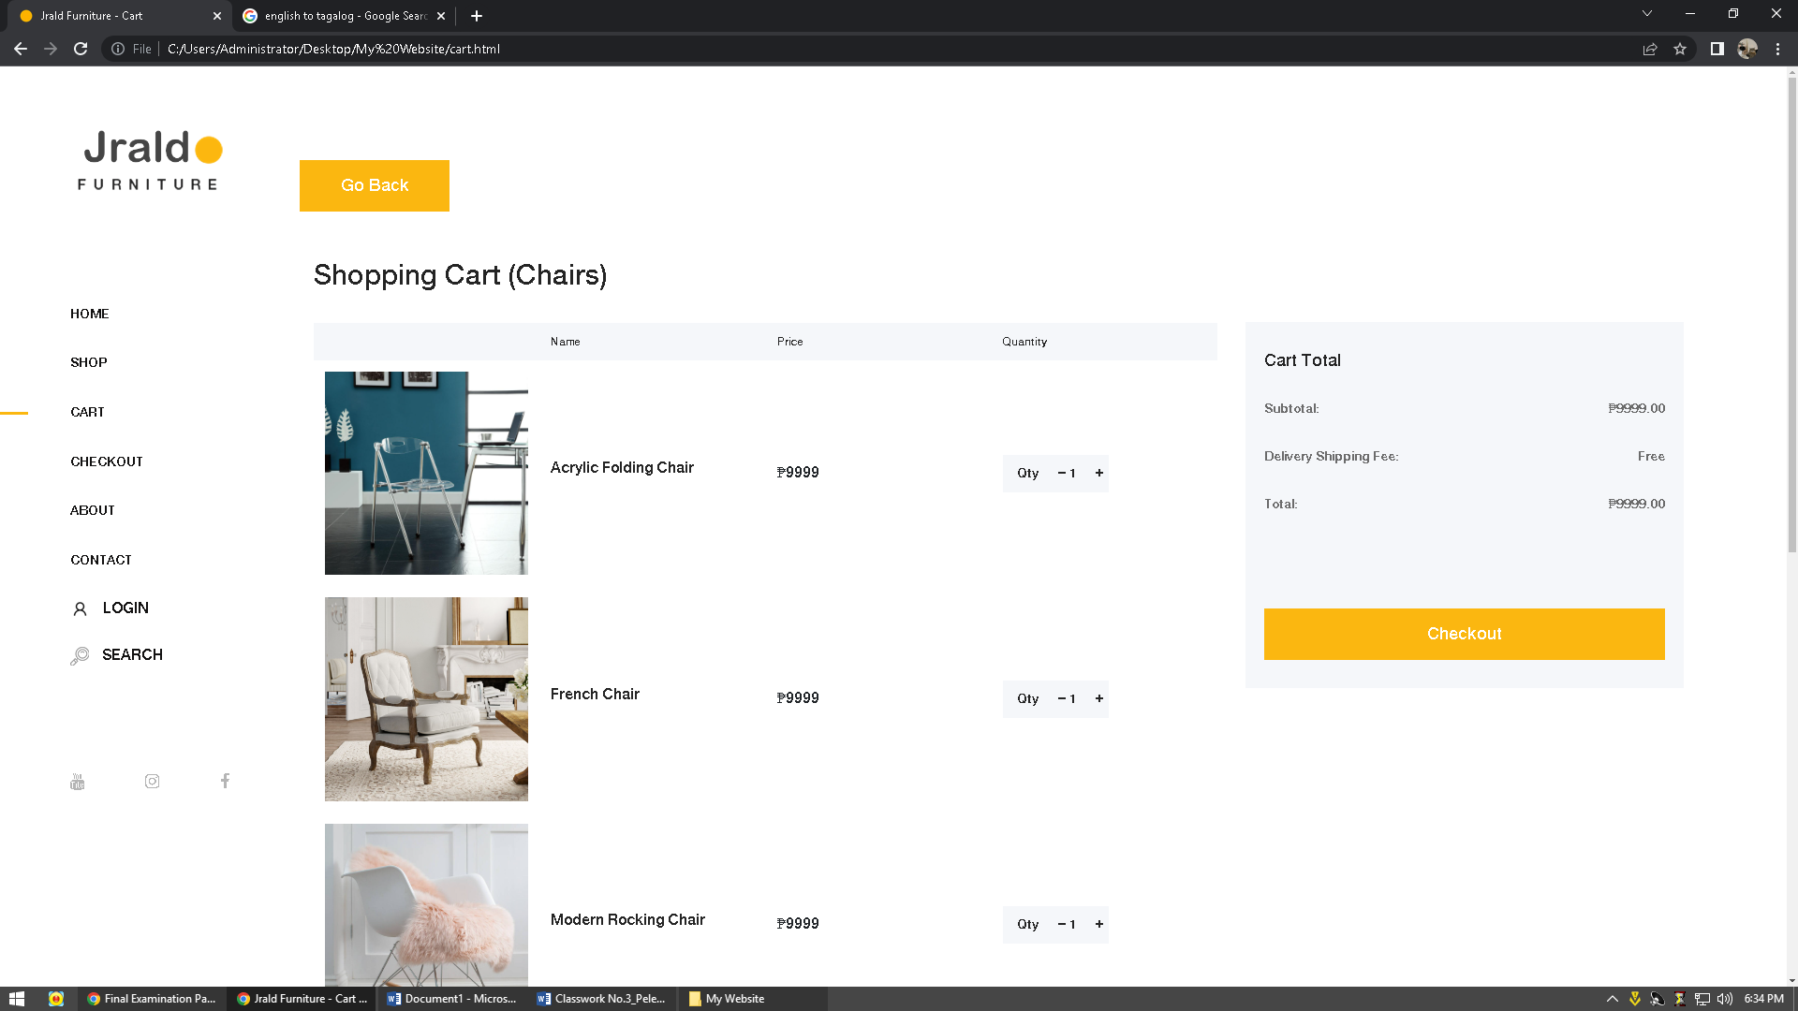

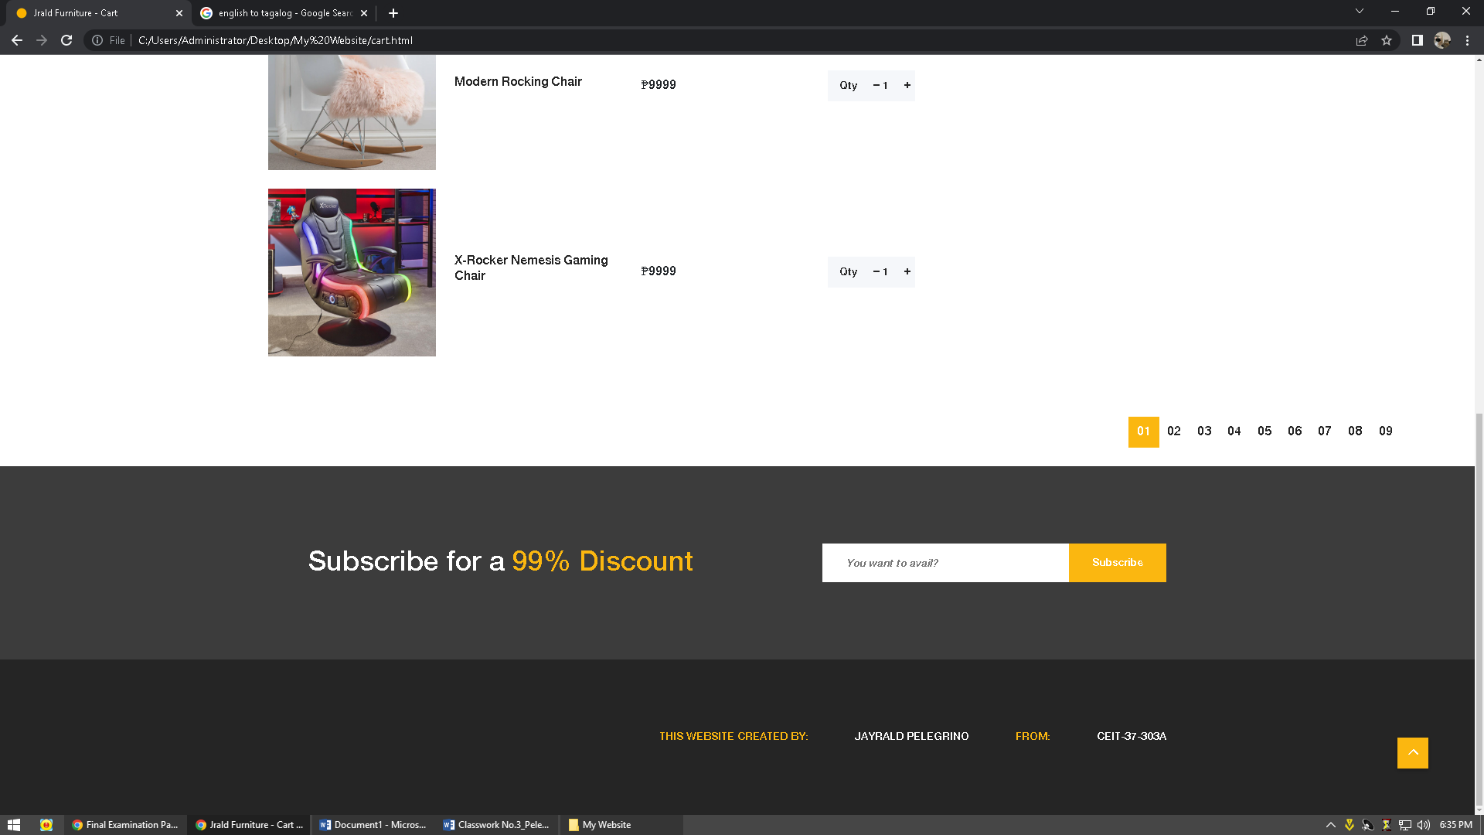

And that's right, he'll go to the shopping cart, I'll go to the cart and see what furniture you've chosen, and everything you see in the screenshot is responsive and working.

**Checkout Page**

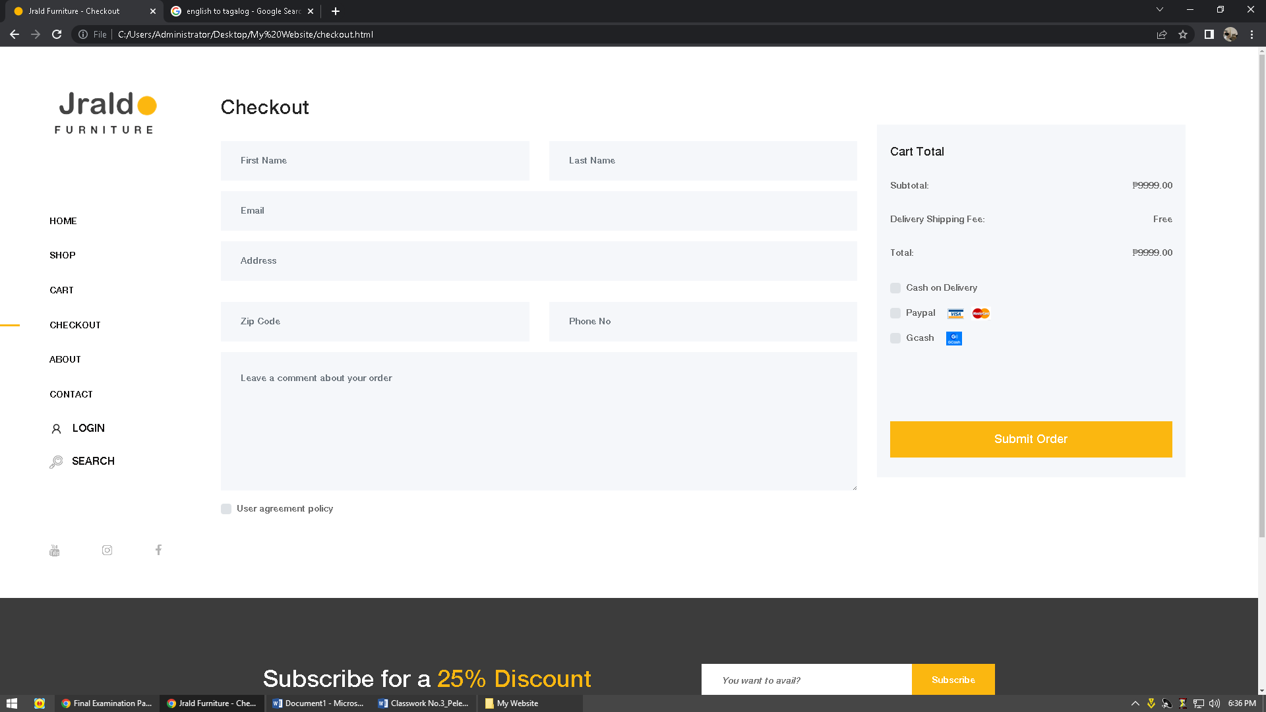

On this page, if you click the checkout or don button on the menu bar of the cart, this is what it will look like if you can see it in the screenshot and if you can see the color scheme that I used and etc. it is only consistent with what's on the other page. And when you submit an order which is my website will respond which is responsive your order is submitted and there is a check sign.

**Login Page**

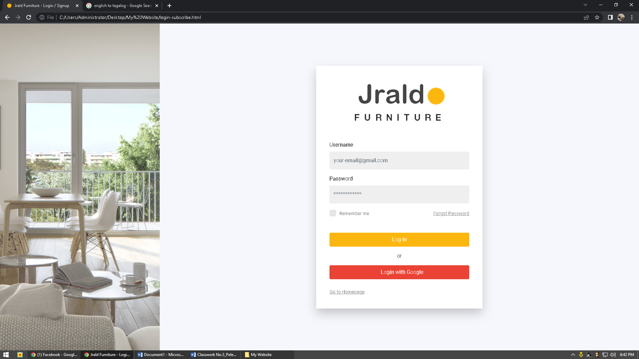

Here on the login page which are the buttons and the check box is responsive which is clickable and he is not even connected to the other link.

but that button can be linked and clickable just include it.

**About Page**

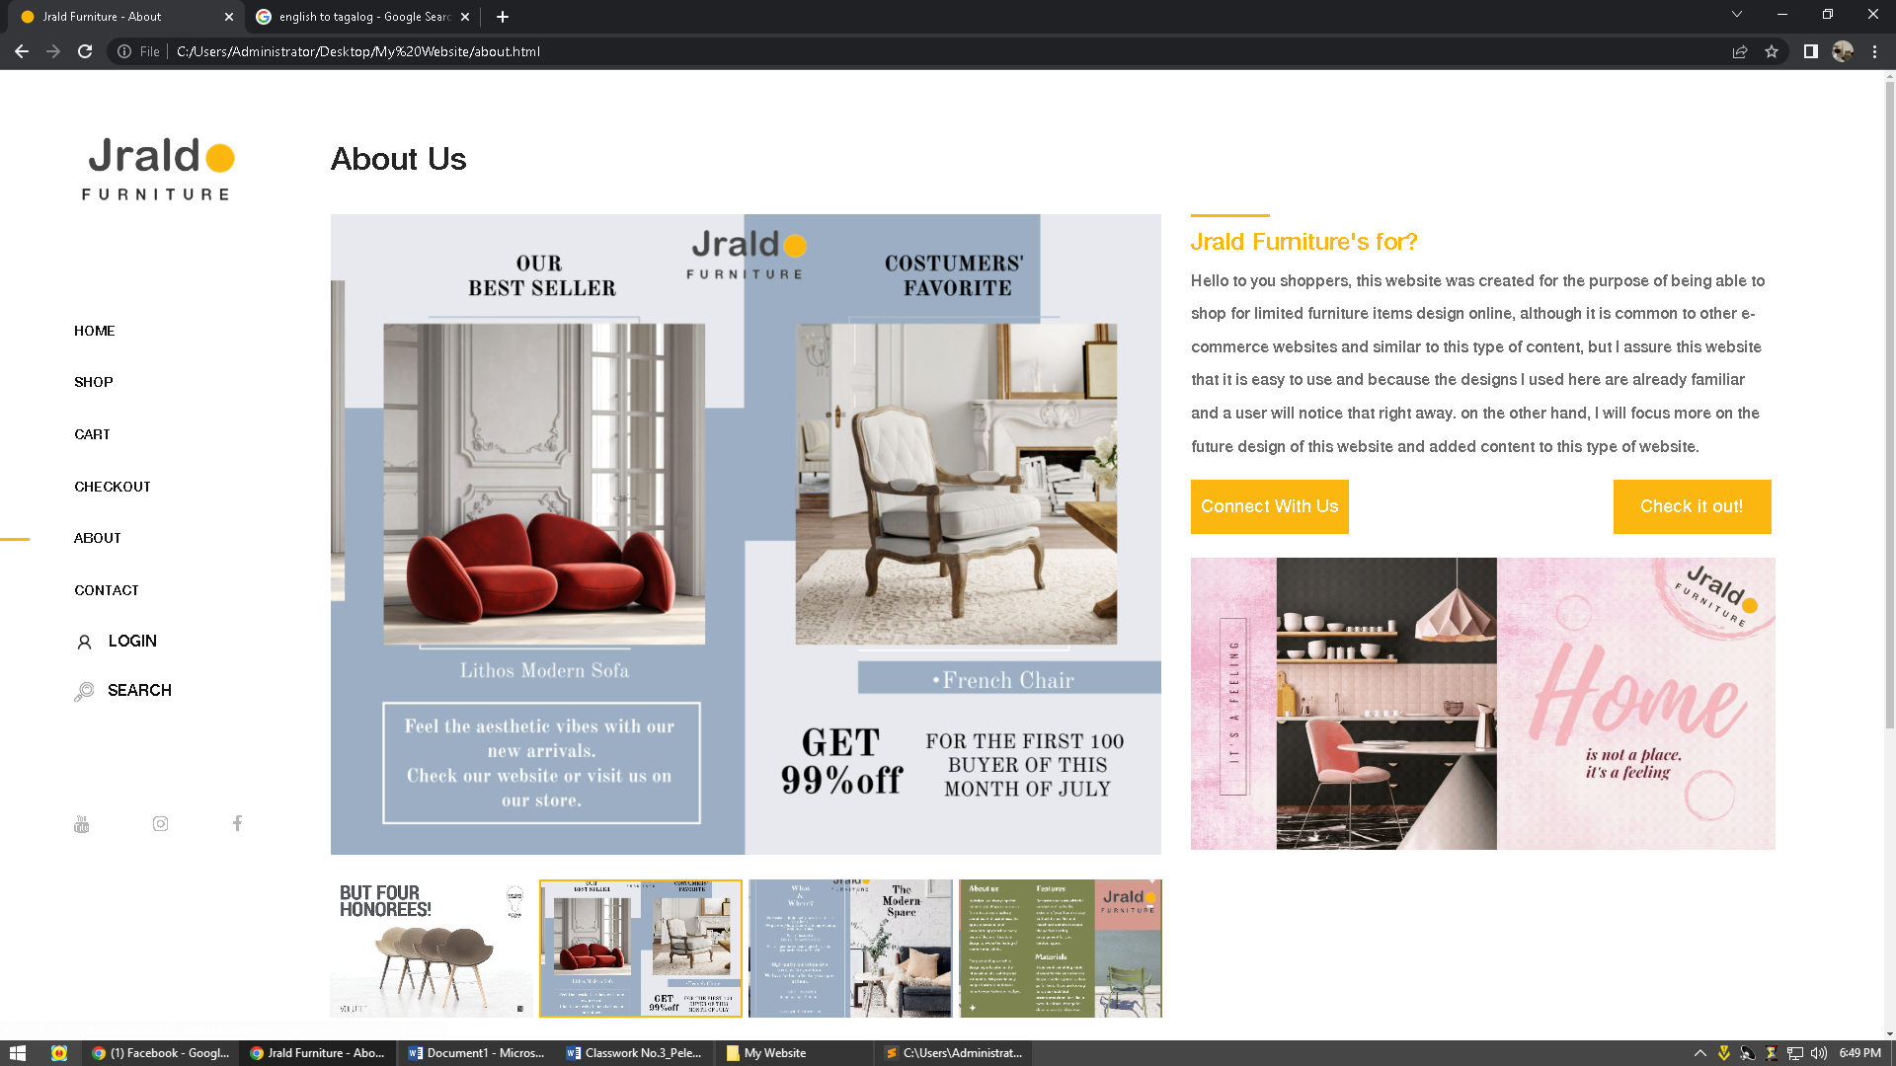

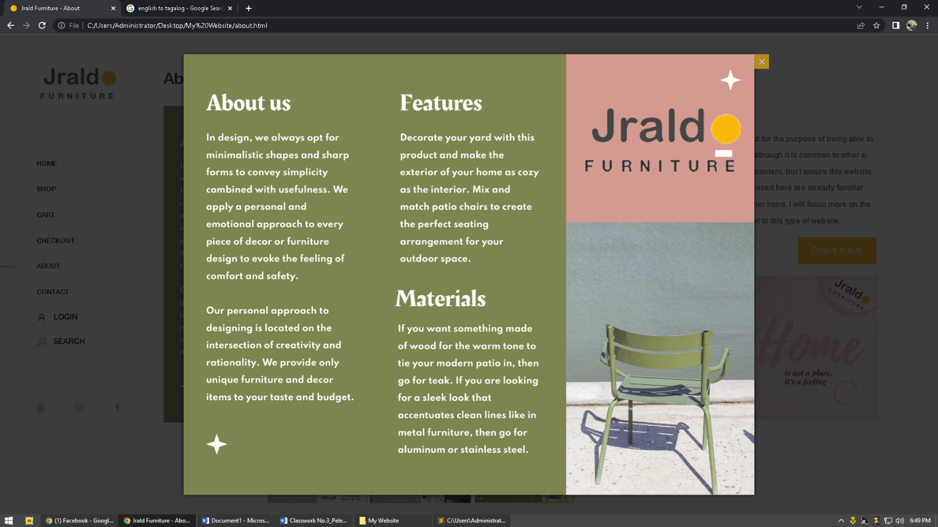

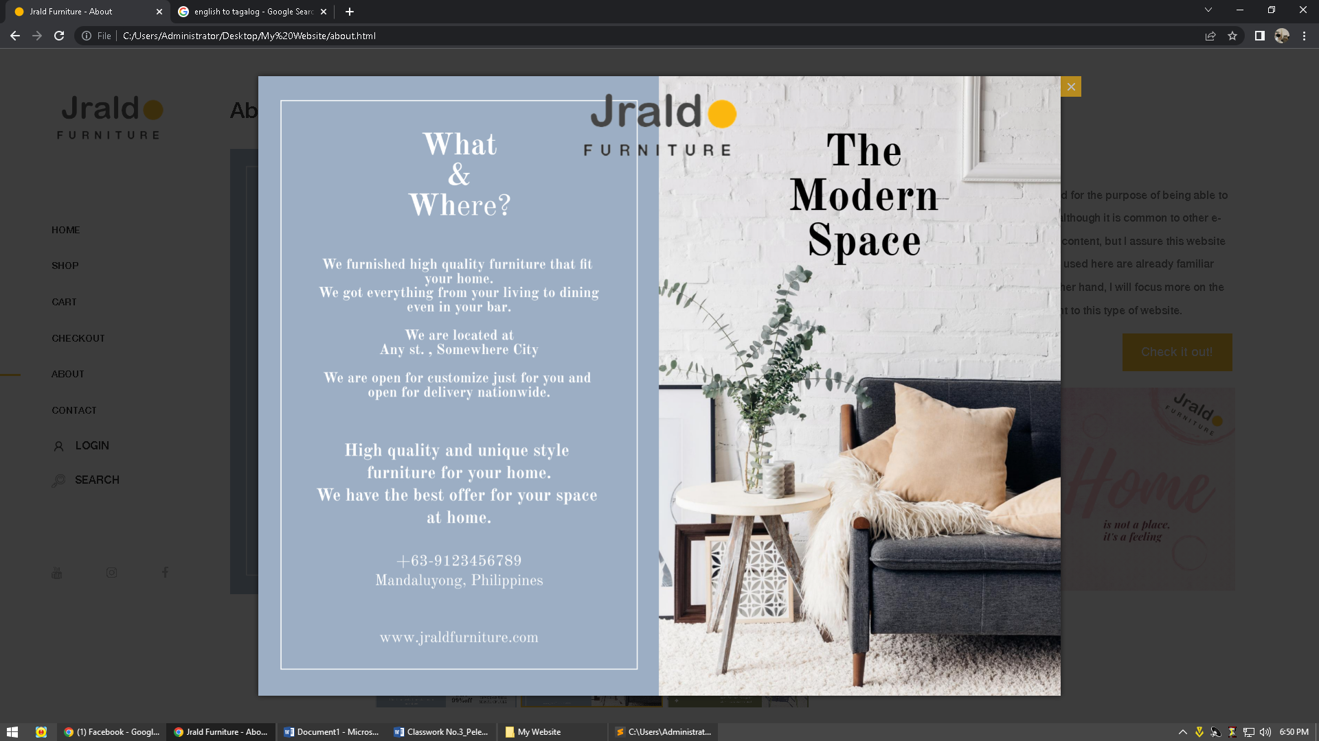

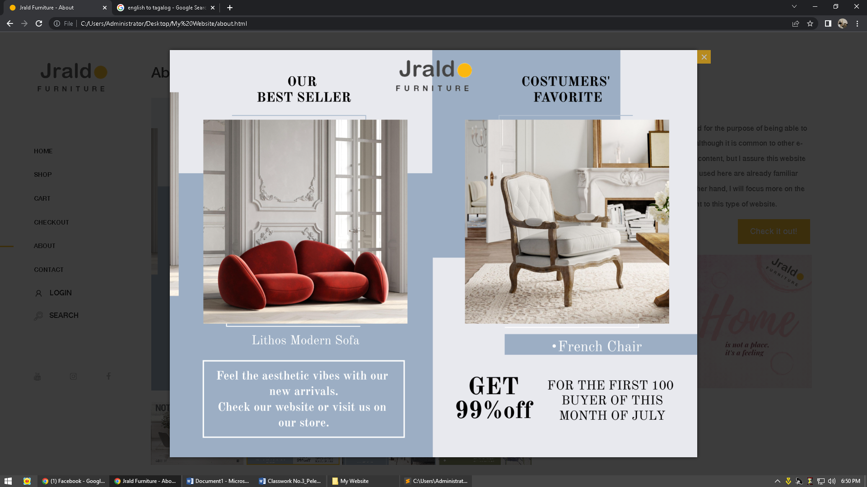

That he zooms once you click the pictures and they are all clickable, and first picture is Gif which means moving picture I used. When you click the connect with us, it will go straight to the contact page, while when you check it out, it will go to the shop page of each furniture.

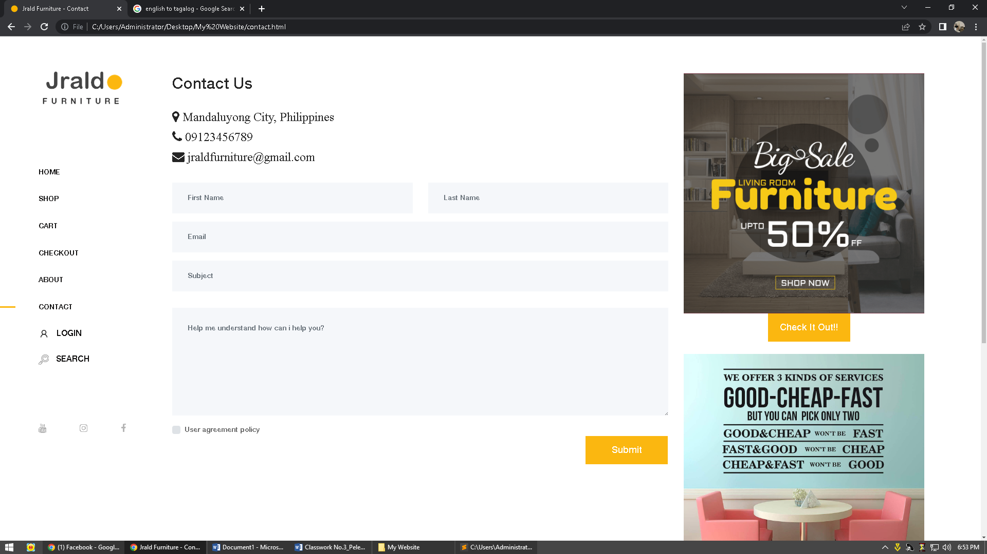

Here on the page which is the contact page, all the buttons and fill up forms are responsive and everyone can use them and then when you submit your request, request submitted will appear. And the check it out button you can see in the screenshot is also directed to the shop page.

**Search Tab**

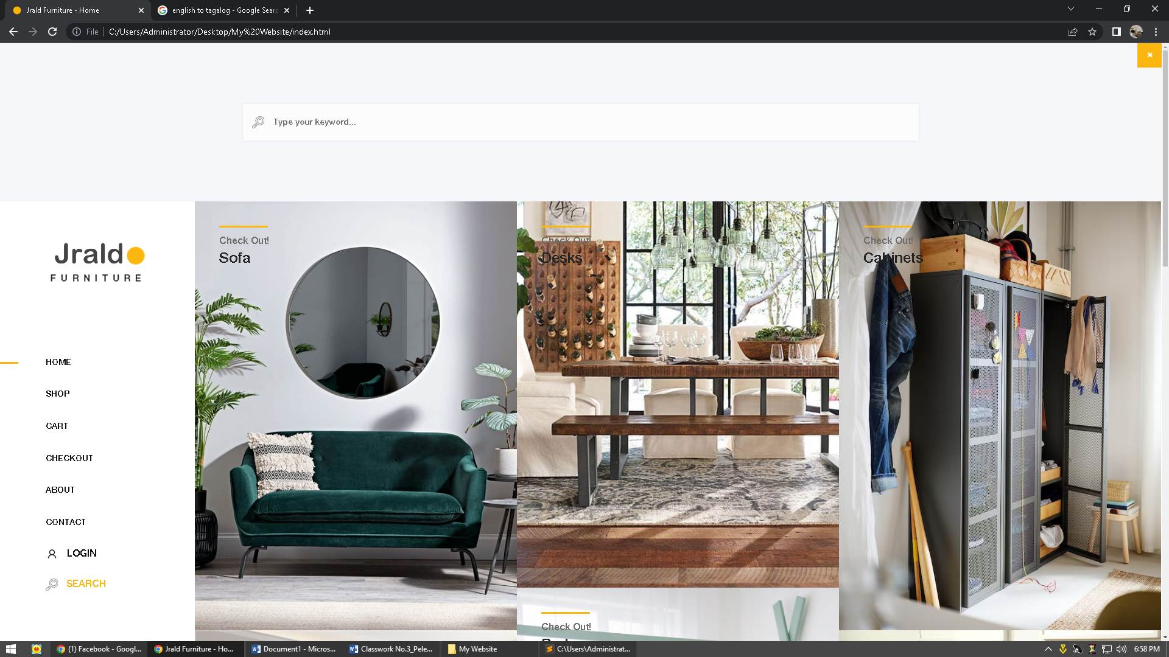

This search bar of ours is not working, but it is not responsive because I just designed it, but it works when I adjust the code. And the close button there in screenshot is working also.

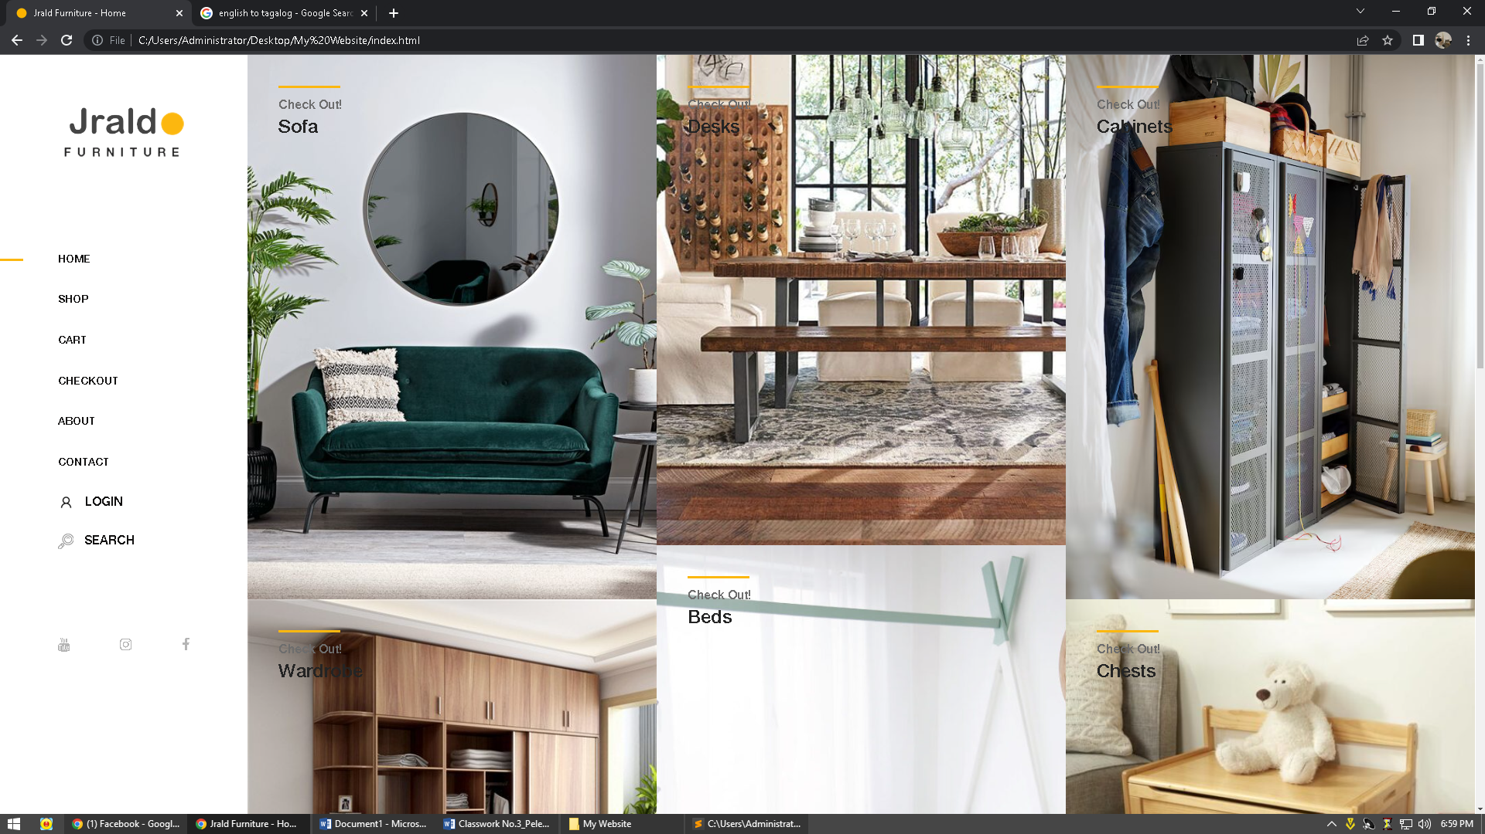

Here on the buttons of the menu bar, everything is working and connected to the hyperlinks to the contents of my website and the one at the bottom which is the social media of this website that I made, which is working when you click those buttons That's why he will redirect to social media accounts.

**Working and Responsive**

**Responsive can Mobile, Tablet, Laptop View**

**Table View**

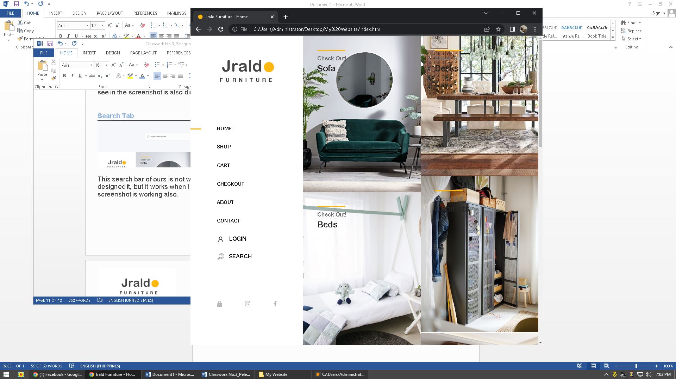

**Mobile View**

